

Library Management System

USER MANUAL

**Term project for CPSC 2301 - Langara College**

**Fall 2012**

**Table of Contents**

Signing Into the Terminal 1

Signing Out of the Terminal 2

Searching Catalog for Resources 2

Adding a Resource 3

View and Changing Resource Information 3

Adding a Resource Copy 3

Disabling a Resource Copy 3

Adding Resource Copies from Reference 4

Removing Resource Copies from Reference 4

Viewing a Resource Subscription 4

Adding a Subscription 5

Removing a Subscription 5

Renewing a Subscription 5

Viewing and Changing a Resource Copy Information 5

Viewing and Changing Fines from Patrons 5

View Currently Checked Out Resources of a User 6

Renewing and Extending a Due Date of Checked Out Material 6

Issuing and Checking Out Material for Patrons 6

Checking In Materials 7

Putting a Resource on Reserve for another User 7

Cancelling Reservations 7

Viewing Checkout Resources 7

Viewing Outstanding Fines 8

Viewing Reserve Resources Of Another User 8

Putting a Resource on Reference 8

Removing a Resource on Reference 8

Viewing the List of Reserved Resources 8

Viewing Resource History 8

Changing a User Type 9

Adding a User 9

Disabling a User 9

Viewing and Changing User Information 9

Importing a List of New Users 10

Viewing All Outstanding Fines for All Users 10

# Libris Main Screen (Administrator’s View)

# 

# Setup Connection to Server

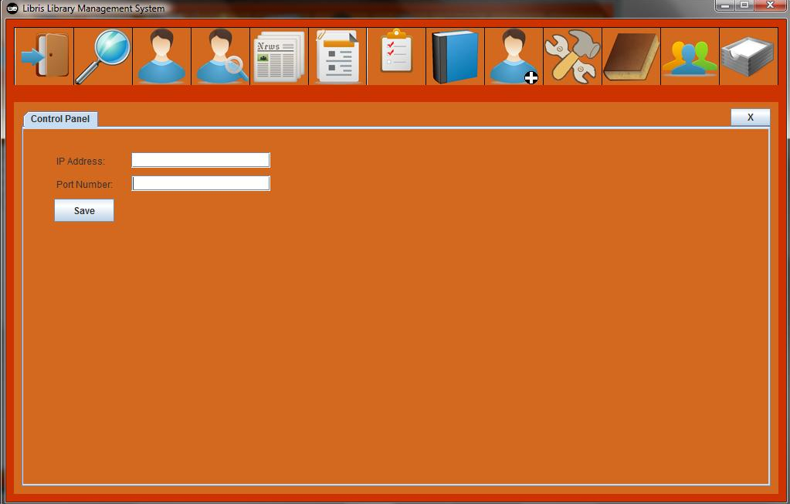

When the program starts the first time you will be prompted to enter the IP Address and the Port Number as agreed with your System Administrator. i.e. 192.168.1.5 Port 1500

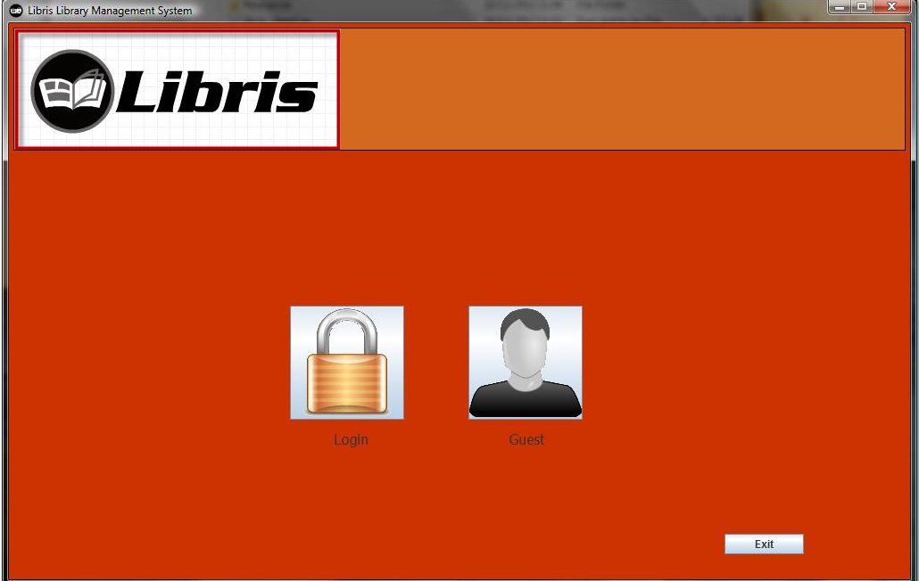

# Signing Into the Terminal

1. Click the Login Button
2. Type in User ID and Password
3. Click Okay

Note: Guests can use the Guest button to browse the catalogue.

# Signing Out of the Terminal

1. Click the Logout button found in the top left corner of the main screen.

# 

# Searching Catalog for Resources

1. Click the search button
2. In the drop down menu select which resource you want to search for
3. Type in any relevant information in the correct field (leaving all fields empty will search for all resources of that type).
4. Click on Search

# 

# Adding a Resource

1. Click the add resource button
2. Select the resource type
3. Enter all relevant information in the correct fields
4. Click Save

# View and Changing Resource Information

1. Click the search button
2. Search for the resource that you are looking for (see searching catalog for resources on page 2)
3. Double click on the resource you which to view and change the information
4. Modify any fields that require to be changed
5. Click the save button

# Adding a Resource Copy

1. Click the search button
2. Search for the resource that you are looking for (see searching catalog for resources on page 2)
3. Double click on the resource you which to add a copy
4. Click resource copies
5. Type in the owner id
6. Click Add

# Disabling a Resource Copy

1. Click the search button
2. Search for the resource that you are looking for (see searching catalog for resources on page 2)
3. Double click on the resource you wish to remove a copy
4. Click resource copies
5. Select the resource you wish to remove
6. Click disabled

# Adding Resource Copies from Reference

1. Click the Search button
2. Search for the resource that you are looking for (see Searching Catalog for Resources)
3. Double click on the resource you wish to add on reference
4. Click on Resource copies
5. Double click on the resource copy you wish to add to references
6. Click on Put on Reference

# Removing Resource Copies from Reference

1. Click the Search button
2. Search for the resource that you are looking for (see Searching Catalog for Resources)
3. Double click on the resource you wish to add on reference
4. Click on Resource Copies
5. Double click on the resource copy you wish to add to references
6. Click on Put on reference

# 

# Viewing a Resource Subscription

1. Click the Subscription button
2. Double click the subscription you wish to view

# Adding a Subscription

1. Click the Subscription button
2. Click on Add
3. Type in all relevant information in the correct fields
4. Click on Save

# Removing a Subscription

1. Click the Subscription button
2. Select the subscription you wish to remove
3. Click on Remove
4. Click OK

# Renewing a Subscription

1. Click the Subscription button
2. Double click the subscription you wish to renew
3. Change the expiration date
4. Click on Save

# Viewing and Changing a Resource Copy Information

1. Click the Search button
2. Search for the resource that you are looking for (see Searching Catalog for Resources)
3. Double click on the resource you wish to see
4. Click resource copies
5. Double click on the resource copy you wish to see
6. Type in all relevant information in the correct fields

# Search User

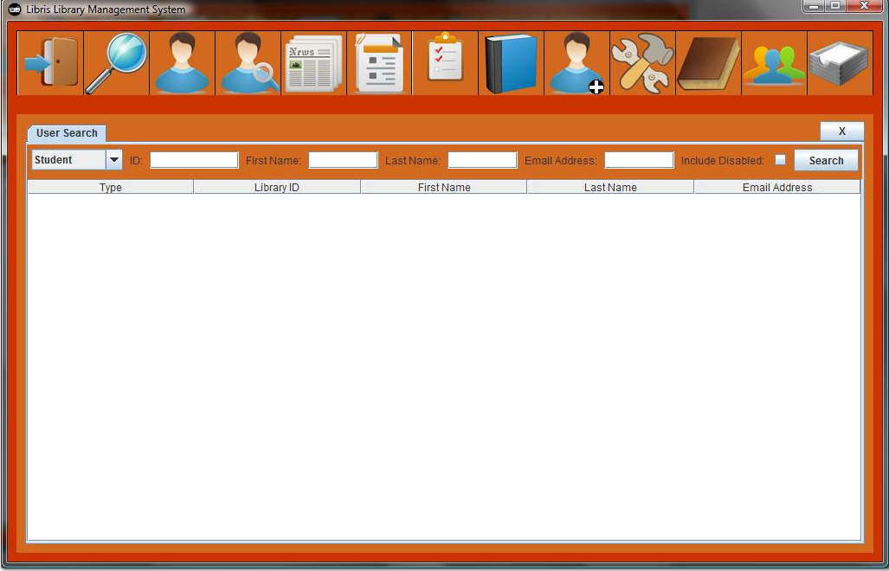

Click on the Search User button.

# Viewing and Changing Fines from Patrons

1. Click on the Search User button
2. In the drop down menu select which type of user you want to search for
3. Type in any relevant information in the correct field (leaving all fields empty will search for all users of that type).
4. Double click on the user
5. Select the fine
6. Press Remove Fine

# View Currently Checked Out Resources of a User

1. Click on the Search user button
2. In the drop down menu select which type of user you want to search for
3. Type in any relevant information in the correct field (leaving all fields empty will search for all users of that type).
4. Double click on the user
5. Click fines

# Renewing and Extending a Due Date of Checked Out Material

1. Click on the Search User button
2. In the drop down menu select which type of user you want to search for
3. Type in any relevant information in the correct field (leaving all fields empty will search for all users of that type).
4. Double click on the user
5. Click on Fines
6. Click on Renew

# Issuing and Checking Out Material for Patrons

1. Click on the Search User button
2. In the drop down menu select which type of user you want to search for
3. Type in any relevant information in the correct field (leaving all fields empty will search for all users of that type).
4. Double click on the user
5. Scan/type in the bar code
6. Click on Check Out

# Checking In Materials

1. Click on the Search User button
2. In the drop down menu select which type of user you want to search for
3. Type in any relevant information in the correct field (leaving all fields empty will search for all users of that type).
4. Double click on the user
5. Click on Check In

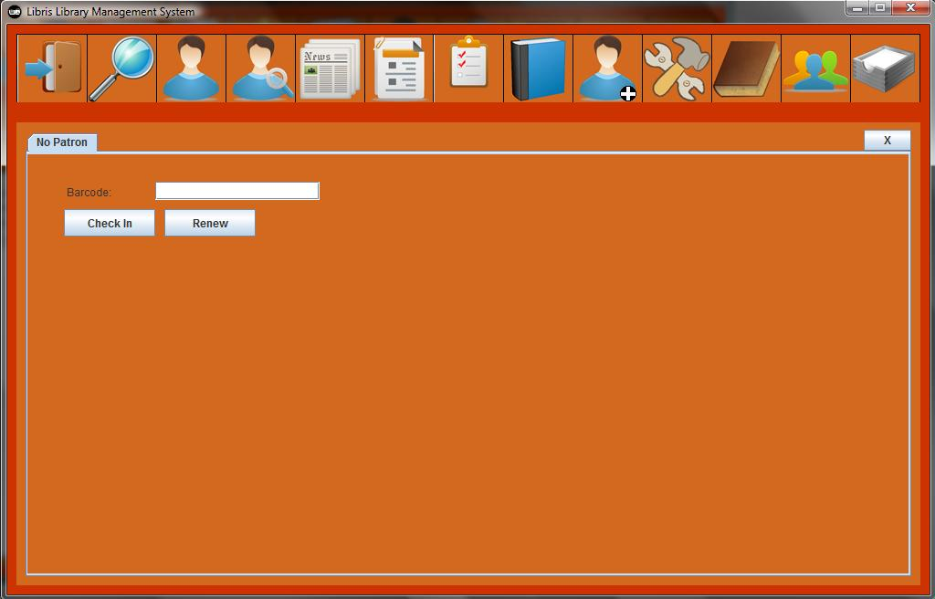

# Putting a Resource on Reserve for another User

1. Click on the Search button
2. Search for the resource that you are looking for (see Searching Catalog for Resources)
3. Double click on the resource you wish to add to reserve
4. Click on Reserves
5. Type in the User ID in the User ID field
6. Click on Add

# Cancelling Reservations

1. Click the search button
2. Search for the resource that you are looking for (see Searching Catalog for Resources)
3. Double click on the resource you wish to remove from reserves
4. Click reserves
5. Select the reserve you wish to cancel
6. Click remove

# Viewing Checkout Resources

1. Click the report button
2. Click the active loans

# Viewing Outstanding Fines

1. Click the Report button

# Viewing Reserve Resources of another User

1. Click on the Search User button
2. In the drop down menu select which type of user you want to search for
3. Type in any relevant information in the correct field (leaving all fields empty will search for all users of that type).
4. Double click on the user
5. Click the reserve

# Putting a Resource on Reference

1. Click my account
2. Click reference
3. Scan/Enter the barcode of the book you wish to put on reference
4. Click Add

# Removing a Resource on Reference

1. Click my account
2. Click reference
3. Select the reference you wish to remove
4. Click remove

# Viewing the List of Reserved Resources

1. Click the Search button
2. Search for the resource that you are looking for (see Searching Catalog for Resources)
3. Double click on the resource you wish to see
4. Click on Reserves

# Viewing Resource History

* 1. Click on the search user button
  2. In the drop down menu select which type of user you want to search for
  3. Type in any relevant information in the correct field (leaving all fields empty will search for all users of that type).
  4. Double click on the user
  5. Click on History

# 

# Changing a User Type

1. Click on the Search User button
2. In the drop down menu select which type of user you want to search for
3. Type in any relevant information in the correct field (leaving all fields empty will search for all users of that type).
4. Double click on the user
5. Click on User Information
6. Choose which type of user you want the user to become in the drop down menu called user type
7. Click on Save

# Adding a User

1. Click Add User
2. Type in any relevant information in the correct field.
3. Click Save

# Disabling a User

1. Click on the Search User button
2. In the drop down menu select which type of user you want to search for
3. Type in any relevant information in the correct field (leaving all fields empty will search for all users of that type).
4. Double click on the user
5. Click on User Information
6. Uncheck enable
7. Click Save

# Viewing and Changing User Information

1. Click on the Search User button
2. In the drop down menu select which type of user you want to search for
3. Type in any relevant information in the correct field (leaving all fields empty will search for all users of that type).
4. Double click on the user
5. Click User Information
6. Change any relevant information in the correct field
7. Click Save

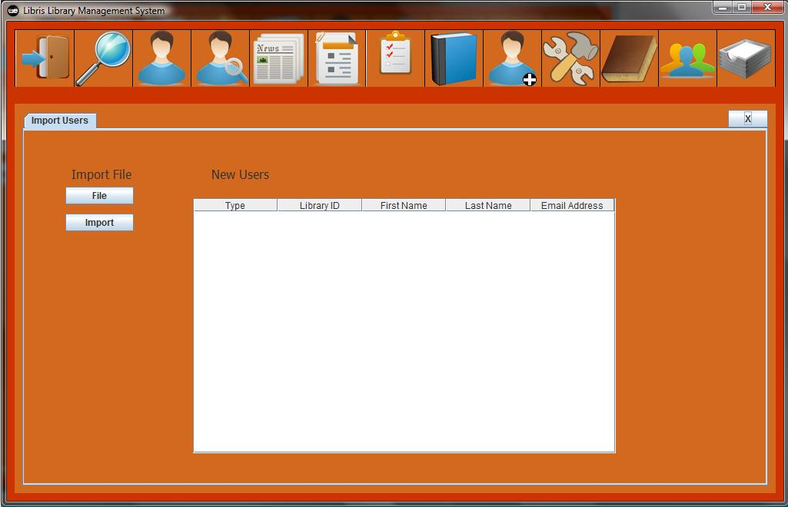

# Importing a List of New Users

1. Click Import User
2. Click File
3. Select the File you wish to import
4. Click Open
5. Click Import

# Viewing All Outstanding Fines for All Users

1. Click Reports